PLAYDAYS PRESCHOOL
CONSUMABLES POLICY

This Policy has been devised in accordance with new EYFS Guidelines dated September 2025.

As from April 2025 we are legally required to inform Parents/Carers of any additional charges we may apply. Our consumables charge is a voluntary charge which we ask Parents to pay each half term. The Government Funding we receive per child does not cover things such as any food, snacks, tissues, nappy sacks, additional costs of parties, cooking, special events or additional resources other than basic resources.

At Playdays we aim to offer the children a wide variety of experiences including cooking, celebrating many different festivals, having lots of sensory exploration involving a variety of resources and much more. Parents are informed as to the reason we ask for this contribution at every half term newsletter.

As stated previously the consumables charge is voluntary however at present the cost we charge per half term equates to approximately 33p per day per child. Over the half term the consumables charge really helps us deliver the experiences we offer the children so that they can thrive and learn through a play based environment.

This Policy was adopted on 1st September 2025

Signed: 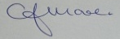 C.J.MOORE/MANAGER
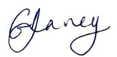 G.V.DAVEY/MANAGER
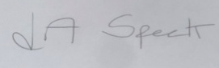 L.A.SPECK/MANAGER

