FUNDED ENTITLEMENT POLICY

Universal 15 hour funding
In line with Government Policy the term after your child’s third birthday they automatically become eligible for 15 hours of funded childcare, subject to availability. At Playdays this is carried out over 38 weeks.

The ‘cut off’ dates for funding are 31st December, 31st March and 31st August. Unfortunately this means that if your child has a birthday on the 1st of the following month they will not receive funding until the following term begins.

If you wish your child to attend for more than 15 hours per week you will need to pay for the additional hours at the hourly rate the setting charges at that time. You will be invoiced every half term with details of fees for the following half term. Invoices will be sent two weeks before the next half term and need to be paid before the start of the new half term. If you are experiencing financial difficulties, please speak to a manager.

Additional forms of Government support - Two Year Old Funding
For your child to receive two year old funding you will need to meet certain criteria. This can be found on the Governments Website searching eligibility for two year old funding. You will need to give us your National Insurance Number, date of birth and full name so that details can be checked. We also require proof of eligibility which is a form of a letter from the London Borough of Sutton. You will also need to complete a Parent Declaration Form. Our two year funded spaces are subject to availability.

Working parent Two/three/four year olds – 30 hour funding
We are able to offer thirty hour places for children at the setting. If a parent wishes to take us this offer they will need to provide the setting with their eligibility code. You will need to apply for the 30 hour code at the government website: Eligibility checker | Best Start in Life. Once again you will be required to complete a Parent’s Declaration Form prior to your child starting at the setting.

The eligibility code will need to be checked every three months and should you become not eligible you will be liable to pay the fees for the additional fifteen hours your child attends for that term.
For further information regarding funding please speak to one of the Managers

This policy was adopted on: 1st September 2025

Signed: 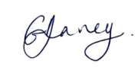 G V DAVEY/MANAGER
Signed: 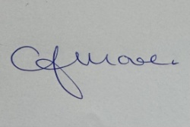 C.J.MOORE/MANAGER

