RISK ASSESSMENT FOR CHILDREN WITH ASTHMA

Early Warning Signs
- Feeling breathless
- Wheezing or whistling sound accompanying breathing
- Coughing

More serious signs
- Difficulty speaking
- Pallor or blueish
- Look carefully at lips and fingernails

ASTHMA ATTACK PROCEDURE AS RECOMMENDED BY ASTHMA US
- Administer reliever inhaler immediately
- Sit child down and ensure that any tight clothing is loosened
- DO NOT LIE CHILD DOWN
- If there is no immediate improvement continue to give one puff of the reliever inhaler every minute for five minutes or until symptoms improve
- If symptoms do not improve in five minutes – or if you are in any doubt call 999 immediately
- Call Parent/Carer
- Continue to give one puff of the reliever inhaler every minute until help arrives

ALWAYS READ EACH CHILD’S HEALTH CARE PLAN/MEDICATION
ADMINISTRATION FORM BEFORE GIVING ANY MEDICATION

This Assessment was updated 18th July 2023 and reviewed 1st September 2025.

Signed: 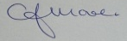 C.J.MOORE/MANAGER
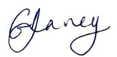 G.V.DAVEY/MANAGER
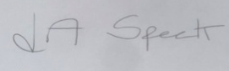 L.A.SPECK/MANAGER

