HEALTH

EYE INFECTION POLICY
Policy Statement

Any child that has an eye infection of any sort will be required to be kept at home until the infection has completely cleared. We will, therefore, be unable to administer eye drops for infections. Unfortunately due to the very contagious nature of eye infections we have had to introduce this policy to ensure the infections are not spread to other children and adults within the setting.

This Policy was adopted on: 8th August 2024 and reviewed 1st September 2025.

Signed: 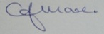 C.J.MOORE/MANAGER
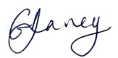 G.V.DAVEY/MANAGER
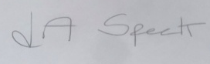 L.A.SPECK/MANAGER

This Policy relates to;
……………………………………………………………………………………………..
……………………………………………………………………………………………..
……………………………………………………………………………………………..

