HEALTH
EXTREME WEATHER/SNOW POLICY
Policy Statement
In the likelihood that extreme weather conditions will force Playdays to close Parents will be informed with as much notice as possible. Playdays will only be closed if Practitioners are unable to safely arrive at the Setting and/or it is deemed unsafe for children to attend.

Procedures
- In the event of adverse weather conditions e.g. severe snow, Playdays Preschool will be closed at the discretion of the Managers
- If the Managers decided it is safest to close the Preschool they will inform Parents by posting on Tapestry and by email. Parents can alternatively telephone 07932730968.
- Any decision to close Playdays will not be undertaken lightly and will only be carried out if there is cause for concern regarding the safety of children, parents and Practitioners travelling to or from the Preschool of during their time at Preschool.

This Policy was adopted on: 7th July 2024 and reviewed 1st September 2025

Signed: 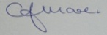 C.J.MOORE/MANAGER
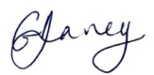 G.V.DAVEY/MANAGER
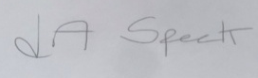 L.A.SPECK/MANAGER

This Policy is in accordance with:
………………………………………………………………………..
………………………………………………………………………..
………………………………………………………………………..

