HEALTH
RISK ASSESSMENT POLICY
POLICY STATEMENT
We aim to ensure that Playdays is a safe and healthy place for children, parents, staff and volunteers. This is achieved by assessing and minimising the hazards and risks to enable the children to thrive in a healthy and safe environment.

Procedures
- A robust risk assessment is undertaken at the start of each academic year. This highlights any signs/areas that need to be dealt with.
- We identify the risk then ascertain who would be at risk: children, staff, parents, visitors etc
- The risk is then assessed as to whether it is high, medium or low level and procedures are put in place to minimise the risk
- The risk assessment process covers both adults and children
- A daily risk assessment is undertaken covering both the indoor and outdoor environment
- Areas requiring immediate attention are dealt with straight away. Low level risks are bought to the attention of the Managers
- Through daily self-evaluation risks are identified and promptly dealt with

This policy was adopted on: 7TH July 2024 and reviewed on 1st September 2025.

Signed: 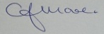 C.J.MOORE/MANAGER
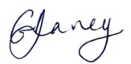 G.V.DAVEY/MANAGER
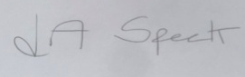 L.A.SPECK/MANAGER

This policy is in accordance with: All Health and Safety Policies

