HEALTH

SUN SAFETY/SUN CREAM POLICY
Policy Statement
Playdays encourages all children to access the outdoor area every day, whether by having freeflow access or structured access. We have shaded areas so that children can still go outside, even in hot weather.
- Parents are required to send their children with a sun hat
- Parents are required to apply long lasting sun cream to their child before leaving their child at the setting. For those children attending all day we ask that you put sun cream in your child’s bag so this can be reapplied after lunch. The sun cream must be a minimum factor of 30. We will keep sun cream at the Setting and will apply if you forget to put some in your child’s bag
- Children will not be allowed outside unless wearing a hat and sun cream
- Children are taught that it is important to ensure that they are ‘sun safe’
- Children are encouraged to drink plenty of water during hot weather.
- All Parent’s must sign to say that they give permission for staff to administer sun cream on their child

This Policy was adopted on 1st September 2025.

Signed: 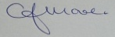 C.J.MOORE/MANAGER
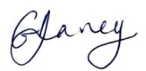 G.V.DAVEY/MANAGER
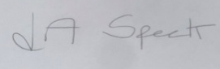 L.A.SPECK/MANAGER

This policy relates to:
……………………………………………………………………
…………………………………………………………………..
…………………………………………………………………..

