PRACTITIONERS

CHILDREN’S ACCESS TO EQUIPMENT POLICY
Policy Statement
To give children autonomy over their learning we include their ideas in our planning and environment. Children are able to access a wide variety of resources which reflect their interests.

Procedures
- Drawers are labelled with visual and written labels
- Resources are regularly changed in accordance with children’s interests
- Storage indoors is arranged in a way that children are able to access resources for themselves
- Children are encouraged to pack away resources when they have finished using them
- Resources such as scissors are available for children to access for themselves, however they are not allowed to walk around the room with scissors. Children are shown how to hold scissors safely when selecting them from drawers and taking them to the table
- Due to a lack of storage in the outdoor area the garden is resourced each morning to cover the seven areas of learning. Once children come outside the resources can be changed according to the children’s interests at that time.

This Policy was adopted on: 22nd August 2023 and reviewed on 1st September 2025.

Signed: 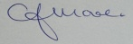 C.J.MOORE/MANAGER
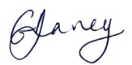 G.V.DAVEY/MANAGER
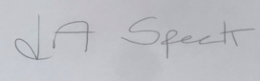 L.A.SPECK/MANAGER

This Policy relates to: All Practitioner Policies, Health and Safety Policies, Curriculum Policies, Outdoor Policy

