SUITABLE PEOPLE
FIRST AID POLICY

Policy Statement
Playdays Preschool commits to Practitioners accessing relevant First Aid Training every three years. At least three Practitioners are on duty at any one time who hold a relevant first aid qualification. All first aid training is relevant to young children and is Local Authority and Ofsted approved.

Procedures
Our first aid kit is checked termly to ensure all of its contents are relevant and in date. The first aid kit is accessible at all times and complies with the Health and Safety First Aid Regulations 1981. The first aid box is accessible to all adults and is kept out of reach of children. A first aid box is always taken on outings. No unprescribed medication is given to children. At the time of each child’s admission to the setting, parents’ written permission for obtaining emergency medical advice or treatment is sought. Parents sign and date their written approval. Parents sign a consent form at registration allowing practitioners to take their child to the nearest hospital to be examined, treated or admitted as necessary on the understanding that parents have been informed and are on their way to the hospital.
If it has been deemed necessary to administer first aid to a child while they are at the Setting the Parent is informed through our online Tapestry Portal.

This Policy was adopted on: 1st September 2025

Signed: 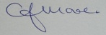 C.J.MOORE/MANAGER
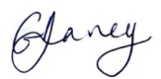 G.V.DAVEY/MANAGER
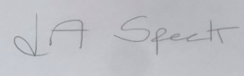 L.A.SPECK/MANAGER
This Policy relates to: Accident Policy Safeguarding Policies, Confidentiality Policies, Health and Safety Policies, GDPR

