HEALTH
NO – SMOKING POLICY/NO VAPING OR USING E-CIGARETTES
Policy Statement
At Playdays we comply with Health and Safety and Safeguarding and Welfare Requirements by making our setting a no-smoking/vaping/e-cigarette environment – both indoors and out.

Procedures
- All staff, parents and volunteers are made aware of our no-smoking policy
- No smoking signs are displayed inside the building
- The No Smoking/Vaping/E-Cigarettes Policy is stated in our information for parents pack
- Staff who smoke do not do so during working hours, unless on a break and off the premises
- Staff who smoke are required to make every effort to reduce the effect of the odour and lingering effects of passive smoking for children and colleagues

This policy was adopted on: 8TH August 2022 and reviewed 1st September 2025

Signed: 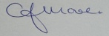 C.J.MOORE/MANAGER
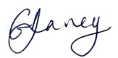 G.V.DAVEY/MANAGER
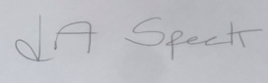 L.A.SPECK/MANAGER

This policy is in accordance with:
……………………………………………………………………
……………………………………………………………………

