SAFEGUARDING

GENERAL DATA PROTECTION/GDPR
Policy Statement
On 25th May 2018 General Data Protection (GDPR) became a legal requirement. All Policies and Procedures regarding Playdays Preschool have been reviewed and updated.

Procedures
- We handle a large amount of Personal Data which includes Parent Details, Childs Details, Staff Details. All of this Data is compliant with new regulations.
- All Parents and staff are informed of what Data we keep, what it is used for and how it is stored
- Personal data will not be taken off the premises without Parents’ permission
- Parents will be asked to sign a Privacy Notice and Permission form when their child starts at the Setting
- Staff have received in-house training and online training to enable them to have an understanding of Data Protection
- A review of the data we held was carried out and only necessary data is now obtained
- We have a named Data Protection Lead:
……………………………………………………

This policy was reviewed on 1st September 2025.

Signed: 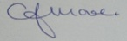 C.J.MOORE/MANAGER
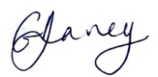 G.V.DAVEY/MANAGER
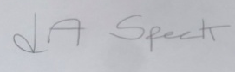 L.A.SPECK/MANAGER

This Policy is in accordance with:
………………………………………………….......
………………………………………………………..
………………………………………………………..

ALL PLAYDAYS POLICIES AND PROCEDURES ARE COMPLIANT WITH GENERAL DATA PROTECTION REGULATIONS

