SUITABLE PEOPLE – ALLEGATIONS OF ABUSE AGAINST MEMBER OF STAFF

Policy Statement
All Parents are made aware of how to make a complaint about a Practitioner, Student or Volunteer Helper working at the Setting, including any allegations of abuse.

Procedures
We follow the guidance when responding to any complaint that a practitioner or volunteer has abused a child. We respond to any disclosure by children, practitioners, parents that abuse by another practitioner may have taken, or is taking place, by first recording the details of any alleged incident. We refer any such complaint immediately to the Local Authority’s Safeguarding Team to investigate (LADO). We co-operate entirely with any investigation carried out by the Safeguarding Team in conjunction with the Police. Our policy is to suspend the Practitioner on full pay for the duration of the investigation: this is not an indication of admission that the alleged incident has taken place, but is to protect the practitioner as well as children and families throughout the process. Where a practitioner or volunteer is dismissed from the setting or internally disciplined because of misconduct relating to a child, we notify the Department of Health Administrators and all relevant agencies so that the name may be included on the List for the Protection of Vulnerable Adults.

This policy was adopted on: 22ND August 2022 and reviewed on 1st September 2025.

Signed: 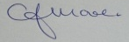 C.J.MOORE/MANAGER
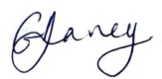 G.V.DAVEY/MANAGER
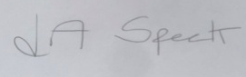 L.A.SPECK/MANAGER

This Policy is in accordance with: Safeguarding Policies, Confidentiality Policies, Employment Policies

