SUITABLE PEOPLE – PRACTITIONER BULLYING

Policy Statement
In the effect of any form of allegations regarding Practitioner bullying certain procedures will be followed to enable a full investigation to be carried out.
Procedures
If an allegation of bullying was made regarding a Practitioner, Student or Volunteer a statement would be taken from the practitioner being bullied in the presence of both Managers. All conversations would be recorded in written form in the Practitioner’s own words. The alleged Practitioner would be interviewed and comments would also be recorded. A meeting would be called between all parties involved to try and solve the situation amicably. The situation would be monitored and if it could not be resolved advice would be sought through the Local Advisory Officer, Preschool Learning Alliance or Ofsted.

This Policy was adopted on: 22nd August 2022 and reviewed on 1st September 2025.

Signed: 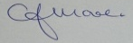 C.J.MOORE/MANAGER
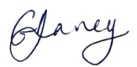 G.V.DAVEY/MANAGER
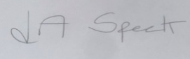 L.A.SPECK/MANAGER

This Policy is in accordance with Safeguarding Policies, Confidentiality Policies, Internal Investigation Policy, Code of Conduct

