SUITABLE PEOPLE
INTERNAL INVESTIGATION POLICY
Policy Statement
If an internal investigation needs to be carried out the Setting will comply with its Safeguarding and Employee Policies.

Procedures
There may be an occasion, due to a variety of reasons, when an internal investigation has to be carried out. If this is deemed necessary then the Managers will contact the London Borough of Sutton’s Early Years Advisory Team and if necessary Ofsted and the Local Safeguarding Team (LADO). Any such investigation will be carried out in a confidential manner by both Managers. If a satisfactory conclusion is found then the case will be closed but if an unsatisfactory conclusion is found then matters will be taken further, according to the nature of the investigation. If for any reason allegations of child abuse are made regarding specific practitioners then that practitioner will be interviewed immediately and asked to leave the setting until a complete investigation has been carried out.

This Policy was adopted on: 22nd August 2022 and reviewed on 1st September 2025.

Signed: 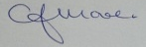 C.J.MOORE/MANAGER
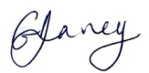 G.V.DAVEY/MANAGER
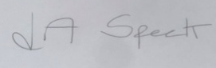 L.A.SPECK/MANAGER

This Policy also relates to Safeguarding Policies, Confidentiality Policies, Employment Policies

