CHILD PROTECTION – SAFEGUARDING

8. SOCIAL MEDIA

Policy Statement

Practitioners are not allowed to have Parents/Carers amongst their contacts on Social Media Sites. Playdays has a public website and a public Instagram account for Parents and Carers to access up to date information on the Setting. Parents/Carers can also access information on their Child’s Tapestry Profile. We also have a Parents/Carers WhatsApp Group which is run by a Parent and is solely for the use of Parents/Carers.

Procedures

The Playdays Website is available for Practitioners and Parents to read and access up to date information on the Setting. Only Managers (and Practitioners with Managers knowledge) have access to the password. This ensures that information and photographs put on the website are monitored. Parents/Carers sign to say that they give consent for photographs of their child to be put on the website.
The Instagram account is a public profile whereby all children and parents who feature have their faces blurred out from recognition. Only Managers (and Practitioners with Managers knowledge) have access to the password. This ensures that information and photographs put on the profile are monitored. Parents/Carers sign to say that they give consent for photographs of their child to be put on the internet.
Parents are made aware in the Playdays Contract that they are not allowed to put photographs of other people’s children on any form of Social Media Site.

This Policy was updated on 1st September 2025.

Signed: 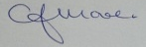 C.J.MOORE/MANAGER/DSL
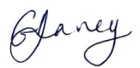 G.V.DAVEY/MANAGER/Deputy DSL
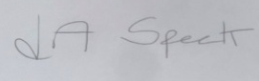 L.A.SPECK/MANAGER

