CHILD PROTECTION – SAFEGUARDING
10. PRACTITIONERS USE OF TAPESTRY

DECLARATION TO BE SIGNED ENSURING THE SAFE USE OF TAPESTRY WHEN USING DEVICES AT HOME

I declare that when using Tapestry at home I will ensure complete professionalism. I will only use tapestry for the purpose of recording observations and uploading photographs of children at the setting. At no time will these be shared with any person that is not employed by Playdays Preschool. When taking devices home from the Setting I will ensure that these devices are transported securely and are not used in a public place and only in the privacy of my own home. If I have used my own device at the Setting I will ensure that Photographs have been uploaded and deleted from my device after they are uploaded to Tapestry.

Carol Moore: ………………………………………………………….
Linda Speck: ………………………………………………………….
Gemma Davey: ………………………………………………………….
Carol Windle: ………………………………………………………….
Maria Monteith: ………………………………………………………….
Beverley Cresswell: ………………………………………………………….
Ralitsa Ivanova: ………………………………………………………….
Samantha Lawler: ………………………………………………………….

This Policy was updated on 1ST September 2023 and reviewed on 1st September 2025

Signed: 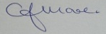 C.J.MOORE/MANAGER/DSL
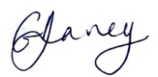 G.V.DAVEY/MANAGER/Deputy DSL
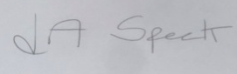 L.A.SPECK/MANAGER

This Policy is in accordance with Playdays Safeguarding Policies, Confidentiality Policy, Use of Mobile Phones and Devices Policy, Tapestry Policy, GDPR Policy

