PLAYDAYS PRESCHOOL
ELECTRICAL EQUIPMENT

Staff must monitor all electrical equipment and ensure it is safe before it is used. This includes computers, photocopiers, televisions, cd players, laminators, Alexa and any other electrical appliance which is used by Playdays. Any faults found must be reported to the Health and Safety Officer/Managers immediately. (Electrical equipment belonging to the Quakers must be safe to use however faults must be bought to the attention of the Caretaker)

Staff are encouraged to:

Monitor the equipment
Use equipment safely and appropriately
Report faults
Switch off electrical equipment when not in use
Only use equipment they are competent to use
NOT carry out repairs unless they are trained to do so
NOT misuse equipment
NOT to overload sockets

PAT testing with be carried out yearly, however equipment is monitored daily
LOG of PAT Testing

DATE | TEST CARRIED OUT BY | COMMENTS
12 Oct 2019 | Colin Speck | All equipment passed
18 Oct 2020 | Colin Speck | All equipment passed
12 Oct 2021 | Quakers | Laminator did not pass  (laminator disposed of and new one purchased)
5th Oct 2023 | Quakers | All equipment passed
8th Oct 2024 | Quakers | All equipment passed
9th Oct 2024 | Quakers | All equipment passed
11th Oct 2025 | Quakers | Blender did not pass (disposed of)  Problem with plug on laptop. Plug changed

Signed: 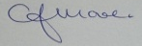 C.J.MOORE/MANAGER
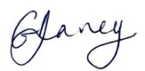 G.V.DAVEY/MANAGER
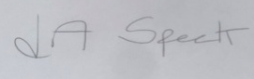 L.A.SPECK/MANAGER

