HEALTH

JELLY CUBE POLICY
Policy Statement

It is the Policy of this Preschool that the use of Jelly Cubes that have not been fully dissolved will not be used in messy play activities. Only set and mashed up jelly will be used as a sensory resource.

This Policy was updated on: 25th August 2025

Signed: 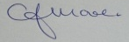 C.J.MOORE/MANAGER
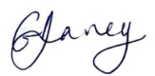 G.V.DAVEY/MANAGER
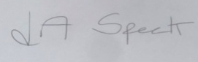 L.A.SPECK/MANAGER

This Policy relates to:
Health and Safety

